Video 6 service workers –

<https://www.youtube.com/watch?v=jy6hX48pRHw>

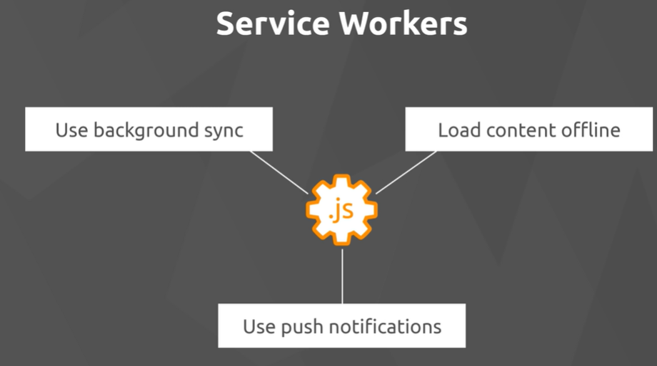

The beating heart of progressive web apps

Load content off line

use backbround sync

use push notifications

Service workers are just javascript files.

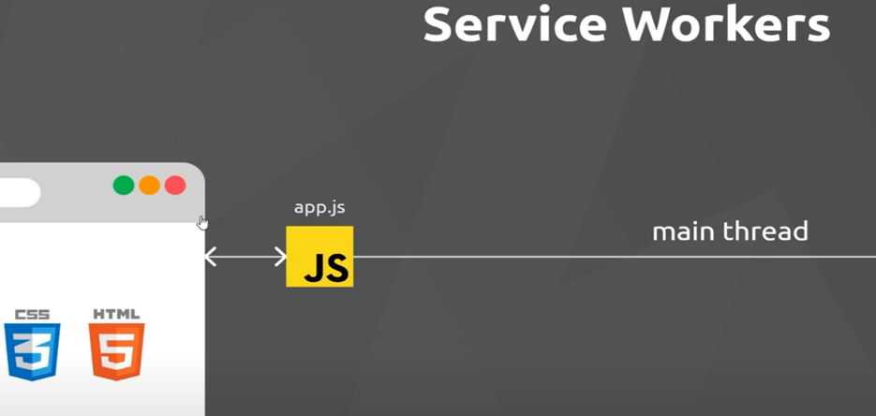

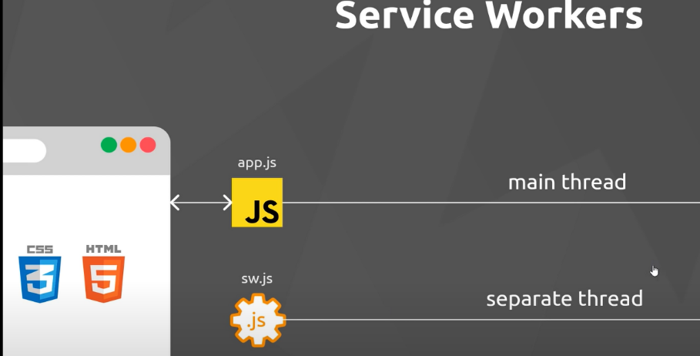

Run in background and handle app like functionality like fetch requests and push notifications – listen for the events .

**They run on a separate thread and do not have access to the DOM. They listen for events and react to them.**

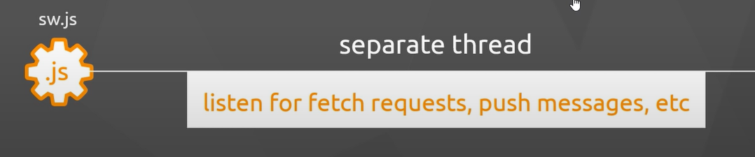

They also listen to lifecycle events